Please fill in this form if you or someone you care for is:
- Worried about their care plan, their placement or going into hospital and
- Has a learning disability and or autism

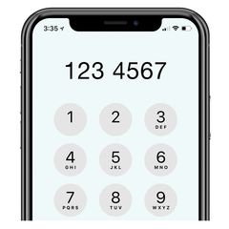
Name and contact details
Name and contact details of person filling in the form
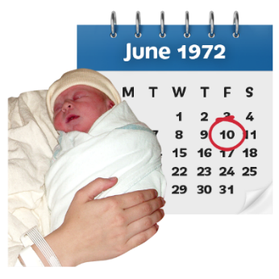
Date of Birth
Are you struggling with any of the below? Please tick Yes or No | Yes | No
Bereavement
Abuse
Pain or distress from physical health issues
Relationship issues
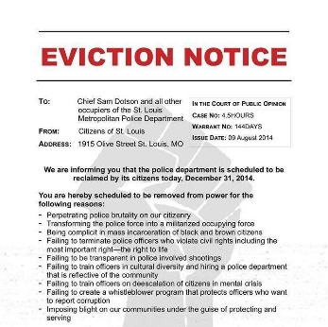
Your placement has given notice of eviction
Difficult emotions about rejection
Eating disorder
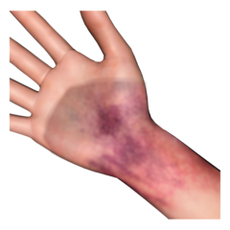
Self-harm
Aggressive behaviour, both physical and verbal
Low mood and withdrawn
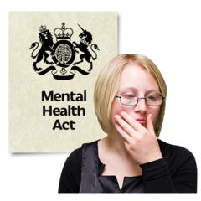
Subject to the Mental Health Act
In contact with the Criminal Justice System
Drug and alcohol addiction
This information will be stored securely and will only be used to help you with the issues you are facing and to help to improve the care you are getting. It may be shared if you are:
- in danger
- at risk of being harmed
- Someone else is at risked of being harmed.
 | It may be shared with people like your social worker, South Tyneside Council, and other organisations in order to help you.
You can contact Your Voice Counts if you have any questions about this form or what we do with your personal information.

Jenny Rohde
0191 478 6472
jenny.rohde@yvc.org.uk

Please tick yes or no to let us know you are happy for us to use and share your information in the way described. | Yes | No
Signature

